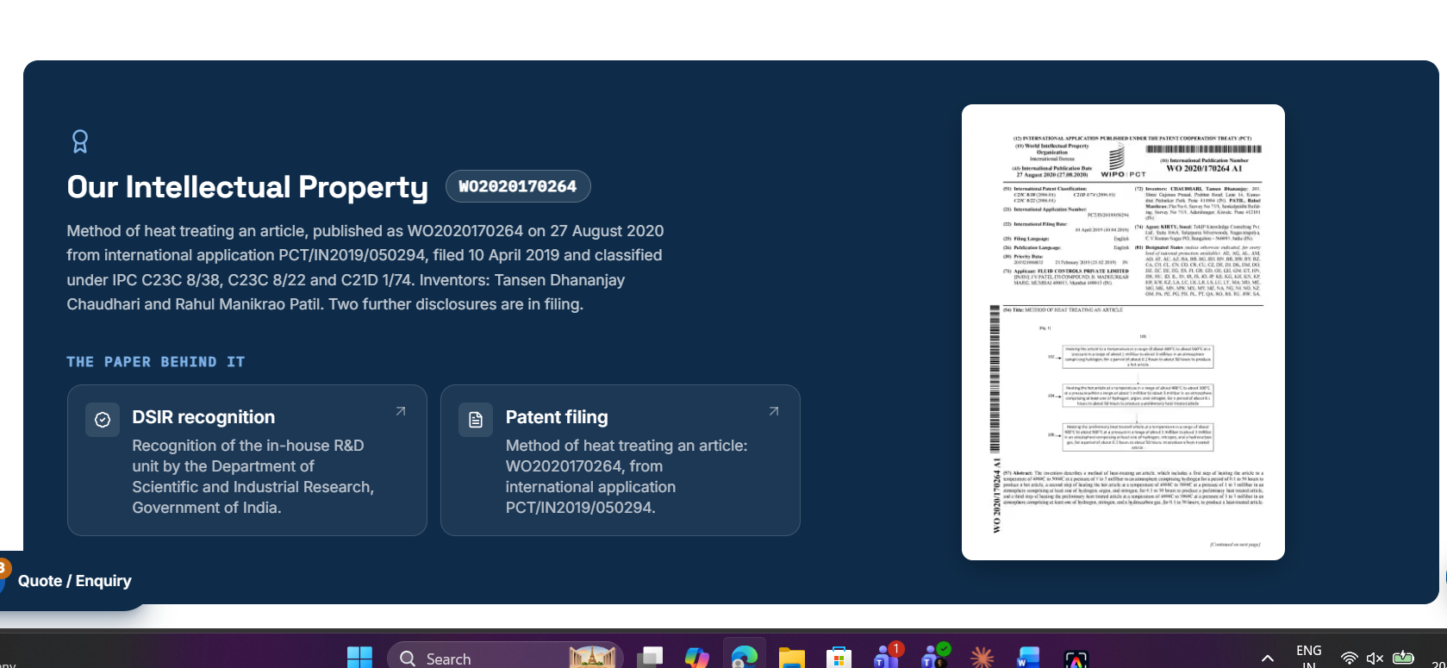
- R&D and Testing Laboratory | Fluid Controls Pune blurry image on page
- Documents section not available (Computational Fluid Dynamics | Fluid Controls)
- Hose Testing | Fluid Controls in section(What we run) link are missing Leakage test, Low and high temperature testing, Salt spray and plating tests, Fire and smoke compliance, Cyclic opening and closing.
- Custom Fabricated Assemblies | Fluid Controls page Documents section missing

